Freeman Houses, owned by two of CT’s first prominent Black women, to be restored by Bridgeport group

The house are some of the last remaining structures of Little Liberia, one of the earliest settlements of free people of color in pre-Civil War Connecticut history.

[JOSEPH TUCCI](https://gcc02.safelinks.protection.outlook.com/?url=https%3A%2F%2Fwww.ctpost.com%2Fauthor%2Fjoseph-tucci%2F&data=05%7C02%7CTodd.Levine%40ct.gov%7C8767fc3c093545af689a08dcf505abdf%7C118b7cfaa3dd48b9b02631ff69bb738b%7C0%7C0%7C638654651975630117%7CUnknown%7CTWFpbGZsb3d8eyJWIjoiMC4wLjAwMDAiLCJQIjoiV2luMzIiLCJBTiI6Ik1haWwiLCJXVCI6Mn0%3D%7C0%7C%7C%7C&sdata=PRNITzrN%2FwM4WdCN5od1GCeLQGQFNsEyOavTObhlSUQ%3D&reserved=0)

March 25, 2023Updated: March 25, 2023 2:58 p.m.

[Comments](https://gcc02.safelinks.protection.outlook.com/?url=https%3A%2F%2Fwww.ctpost.com%2Frealestate%2FarticleComments%2Fmary-and-eliza-freeman-houses-restore-bridgeport-17854386.php&data=05%7C02%7CTodd.Levine%40ct.gov%7C8767fc3c093545af689a08dcf505abdf%7C118b7cfaa3dd48b9b02631ff69bb738b%7C0%7C0%7C638654651975642759%7CUnknown%7CTWFpbGZsb3d8eyJWIjoiMC4wLjAwMDAiLCJQIjoiV2luMzIiLCJBTiI6Ik1haWwiLCJXVCI6Mn0%3D%7C0%7C%7C%7C&sdata=rKKhRcikLBX4zVF5iGfI3K%2FQjC2wSxEa5fn%2BQxMDIb8%3D&reserved=0)

15

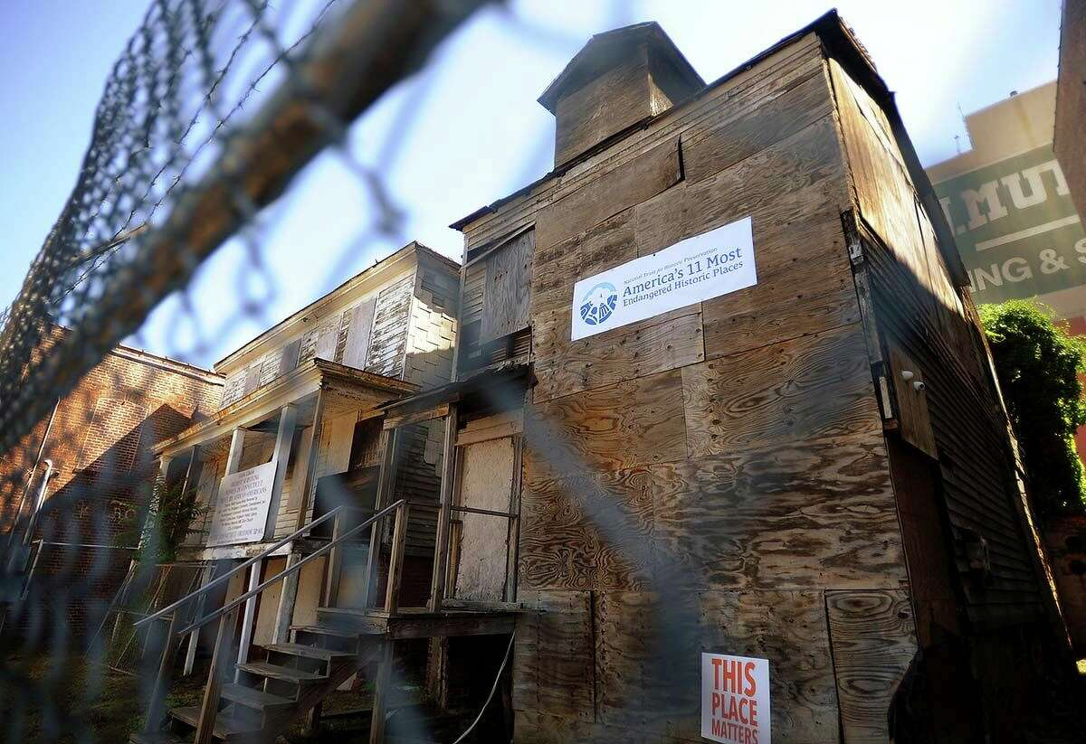1of15The Mary and Eliza Freeman houses at 354 Main Street in Bridgeport in 2018.Brian A. Pounds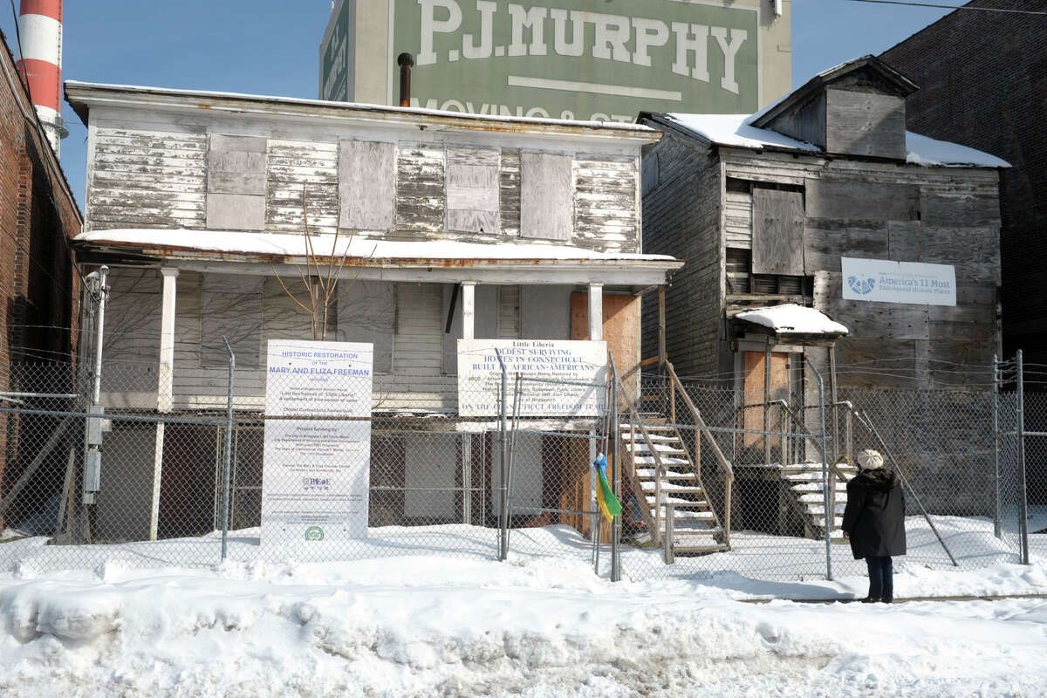

Along Main Street in Bridgeport sit two boarded-up houses that, despite their current state of disrepair, tell the tale of two of the most prominent Black women in pre-Civil War Connecticut history. One group in Bridgeport has been working to bring the structures back to their former glory and turn them into a museum and community center.

The houses were built in the 1840s. They were owned by sisters Mary and Eliza Freeman, two Black women born into freedom in Derby in the early 1800s; slavery was practiced in Connecticut until 1848. Mary (born 1815) and Eliza (born 1805) Freeman worked and lived in New York City, but purchased the Bridgeport houses as rental properties, according to the [National Park Service](https://gcc02.safelinks.protection.outlook.com/?url=https%3A%2F%2Fwww.nps.gov%2Fplaces%2Fmary-and-eliza-freeman-houses.htm%23%3A~%3Atext%3DCompleted%2520in%2520the%2520late%25201840s%2Coutbreak%2520of%2520the%2520Civil%2520War.&data=05%7C02%7CTodd.Levine%40ct.gov%7C8767fc3c093545af689a08dcf505abdf%7C118b7cfaa3dd48b9b02631ff69bb738b%7C0%7C0%7C638654651975655760%7CUnknown%7CTWFpbGZsb3d8eyJWIjoiMC4wLjAwMDAiLCJQIjoiV2luMzIiLCJBTiI6Ik1haWwiLCJXVCI6Mn0%3D%7C0%7C%7C%7C&sdata=lRiMfZQwweNYm7geNKp9hbhl2RIBK5G0%2B9GJr%2F%2FOHT4%3D&reserved=0). Eventually, both sisters moved into the Bridgeport houses and lived there until their deaths.

The houses are the last existing structures of Little Liberia, a neighborhood where free African Americans settled between 1831 and the start of the Civil War. In 1999, they were added to the National Register of Historic Places. Archeological digs at the site have uncovered items dating back to the time the Freemans owned the properties including a teapot, a bottle of toothpowder, a soup dish, a toothbrush handle, a porcelain doll leg, a clay marble, the metal wheel from a wagon and a broken doll.

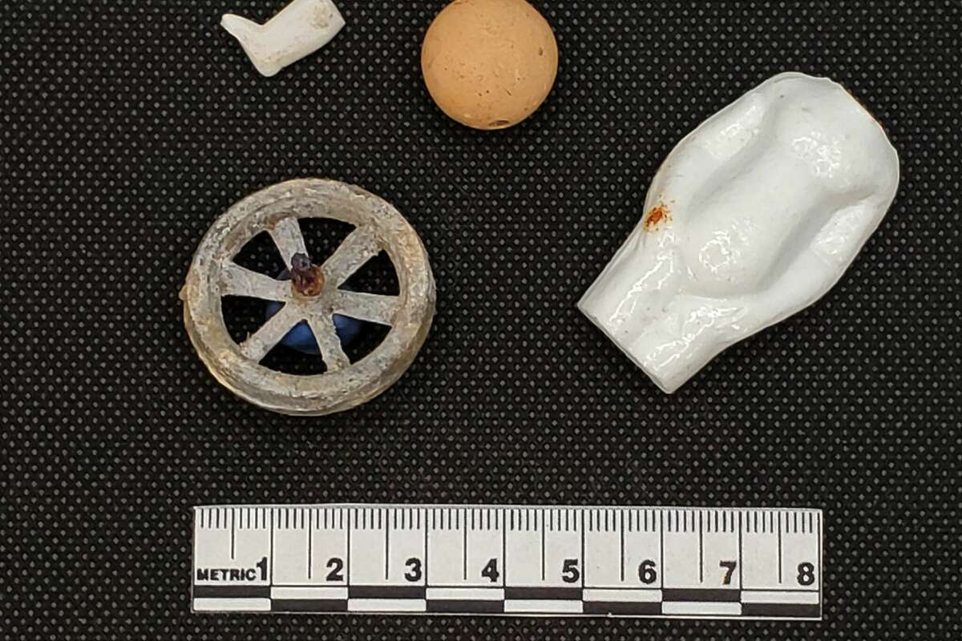

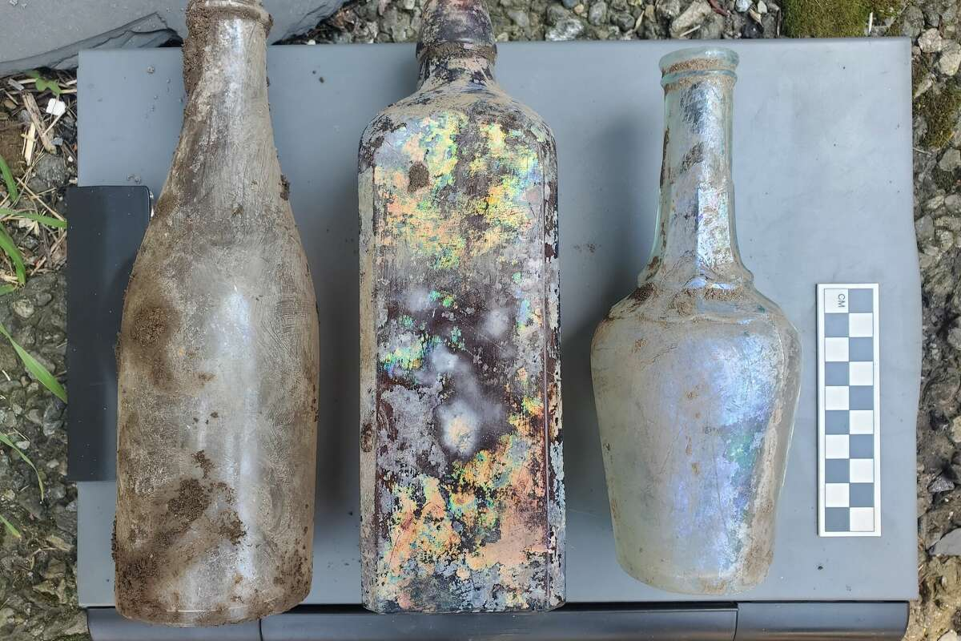

Items found in the ground at the Mary and Eliza Freeman houses. Office of State Archaeology / contributed

The houses are also part of [Connecticut's Freedom Trail](https://gcc02.safelinks.protection.outlook.com/?url=https%3A%2F%2Fwww.ctinsider.com%2Fprojects%2Fguides%2Fconnecticut-freedom-trail-map%2F&data=05%7C02%7CTodd.Levine%40ct.gov%7C8767fc3c093545af689a08dcf505abdf%7C118b7cfaa3dd48b9b02631ff69bb738b%7C0%7C0%7C638654651975668822%7CUnknown%7CTWFpbGZsb3d8eyJWIjoiMC4wLjAwMDAiLCJQIjoiV2luMzIiLCJBTiI6Ik1haWwiLCJXVCI6Mn0%3D%7C0%7C%7C%7C&sdata=a7zn1RCaS2VVgNkoB8eErPUmWCw6gWKWxxY1dObsSJ8%3D&reserved=0), which traces the histories of freed Black Americans and those born into freedom in Connecticut. According to the Bridgeport History Center, Little Liberia was a stop along the [Underground Railroad](https://gcc02.safelinks.protection.outlook.com/?url=https%3A%2F%2Fbportlibrary.org%2Fhc%2Fafrican-american-heritage%2Fmary-and-eliza-freeman-houses%2F&data=05%7C02%7CTodd.Levine%40ct.gov%7C8767fc3c093545af689a08dcf505abdf%7C118b7cfaa3dd48b9b02631ff69bb738b%7C0%7C0%7C638654651975681642%7CUnknown%7CTWFpbGZsb3d8eyJWIjoiMC4wLjAwMDAiLCJQIjoiV2luMzIiLCJBTiI6Ik1haWwiLCJXVCI6Mn0%3D%7C0%7C%7C%7C&sdata=Urjxy%2BG3l5E%2F502zLGSxANJ3o82y9zP%2BliHWisEgw1E%3D&reserved=0).

According to forms filed with the [National Register](https://gcc02.safelinks.protection.outlook.com/?url=https%3A%2F%2Fnpgallery.nps.gov%2FNRHP%2FGetAsset%2FNRHP%2F99000110_text&data=05%7C02%7CTodd.Levine%40ct.gov%7C8767fc3c093545af689a08dcf505abdf%7C118b7cfaa3dd48b9b02631ff69bb738b%7C0%7C0%7C638654651975694312%7CUnknown%7CTWFpbGZsb3d8eyJWIjoiMC4wLjAwMDAiLCJQIjoiV2luMzIiLCJBTiI6Ik1haWwiLCJXVCI6Mn0%3D%7C0%7C%7C%7C&sdata=NP1B6OqFImP5uCKEUjNnbUrmhGQ09eCsNb2tlVL2TQs%3D&reserved=0), Mary Freeman had between $30,000 and $50,000 in property by the time of her death, which is the equivalent of about [$1.5 million today](https://gcc02.safelinks.protection.outlook.com/?url=https%3A%2F%2Fwww.officialdata.org%2Fus%2Finflation%2F1883%3Famount%3D50000&data=05%7C02%7CTodd.Levine%40ct.gov%7C8767fc3c093545af689a08dcf505abdf%7C118b7cfaa3dd48b9b02631ff69bb738b%7C0%7C0%7C638654651975709537%7CUnknown%7CTWFpbGZsb3d8eyJWIjoiMC4wLjAwMDAiLCJQIjoiV2luMzIiLCJBTiI6Ik1haWwiLCJXVCI6Mn0%3D%7C0%7C%7C%7C&sdata=Q6CqBfUVe1e9WXfI4aeQqgXlFUsovbRrUUIfQreOmhs%3D&reserved=0).

The houses are in need of significant repair but Charles Brilvitch, a board member with the [Mary and Eliza Freeman Center](https://gcc02.safelinks.protection.outlook.com/?url=https%3A%2F%2Ffreemancenterbpt.org%2Flittleliberia.html&data=05%7C02%7CTodd.Levine%40ct.gov%7C8767fc3c093545af689a08dcf505abdf%7C118b7cfaa3dd48b9b02631ff69bb738b%7C0%7C0%7C638654651975722251%7CUnknown%7CTWFpbGZsb3d8eyJWIjoiMC4wLjAwMDAiLCJQIjoiV2luMzIiLCJBTiI6Ik1haWwiLCJXVCI6Mn0%3D%7C0%7C%7C%7C&sdata=p0G45ILAWXBJT%2FpYwA6RyiajwPPxmKDd001OzlG4hOY%3D&reserved=0) for History and Community, said they are still recognizable on the inside.

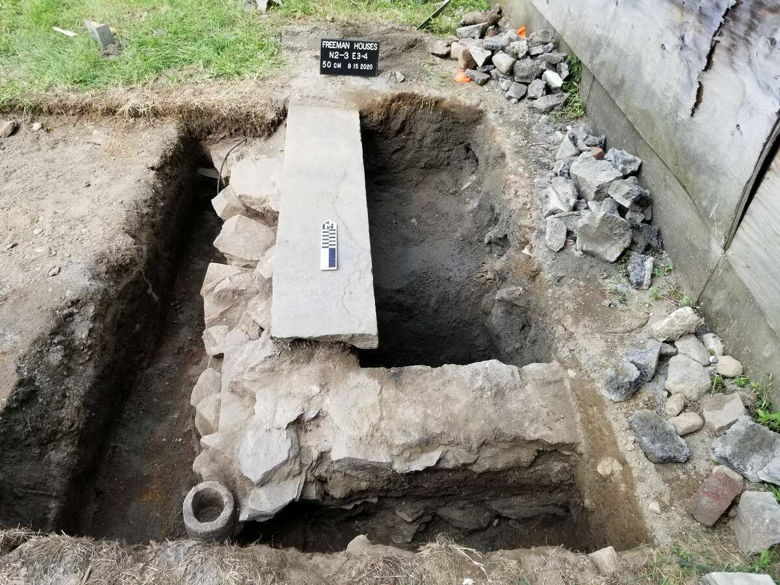

2020 excavation of the front porch area of the Eliza Freeman House.

Office of State Archaeology., Photograph by Sarah Sportman

"What's amazing is that you go into Mary's house, and it's like nothing was ever changed. They have got all the 1840s doors with thumb lanches instead of door nobs, tiny little staircases," Brilvitch said. "The whole first floor was like a gigantic kitchen."

The Freeman Center is a Black-led, grassroots, nonprofit organization. It was formed in 2009 by a group of local activists and community leaders  to restore and preserve the houses and other historic Bridgeport areas.

"Our work is driven by a commitment to preserving African American historic places, empowering Black and Indigenous people by restoring their narratives, healing through history, and preservation-based equitable development," Maisa L. Tisdale, president of the Freeman Center, said.

The group purchased the properties from the city in 2010 and has spent years working on restorations. Tisdale said a 2018 estimate to restore the houses and build a [heritage and education center](https://gcc02.safelinks.protection.outlook.com/?url=https%3A%2F%2Ffreemancenterbpt.org%2Fgoals.html&data=05%7C02%7CTodd.Levine%40ct.gov%7C8767fc3c093545af689a08dcf505abdf%7C118b7cfaa3dd48b9b02631ff69bb738b%7C0%7C0%7C638654651975735109%7CUnknown%7CTWFpbGZsb3d8eyJWIjoiMC4wLjAwMDAiLCJQIjoiV2luMzIiLCJBTiI6Ik1haWwiLCJXVCI6Mn0%3D%7C0%7C%7C%7C&sdata=9wQ6LBoEUMElWiysl6qC182YAn1LmWZe%2F4bQ4K%2BoDq4%3D&reserved=0) had the project budgeted at $2.7 million. By spring 2020, the Freeman Center raised $2.1 million and was ready to move forward with a bid to select a construction company when the COVID-19 pandemic struck, forcing the project's delay. By the time the project was able to begin again, the rising cost of building materials due to inflation and supply chain issues ballooned the budget.

Tisdale said it would now cost around $8 million to complete the project.

"Our jaws just dropped. We were so disappointed, another delay. But we immediately began writing proposals and applying for grants," Tisdale said. "The only thing delaying the restoration and opening of the Freeman Houses is money."



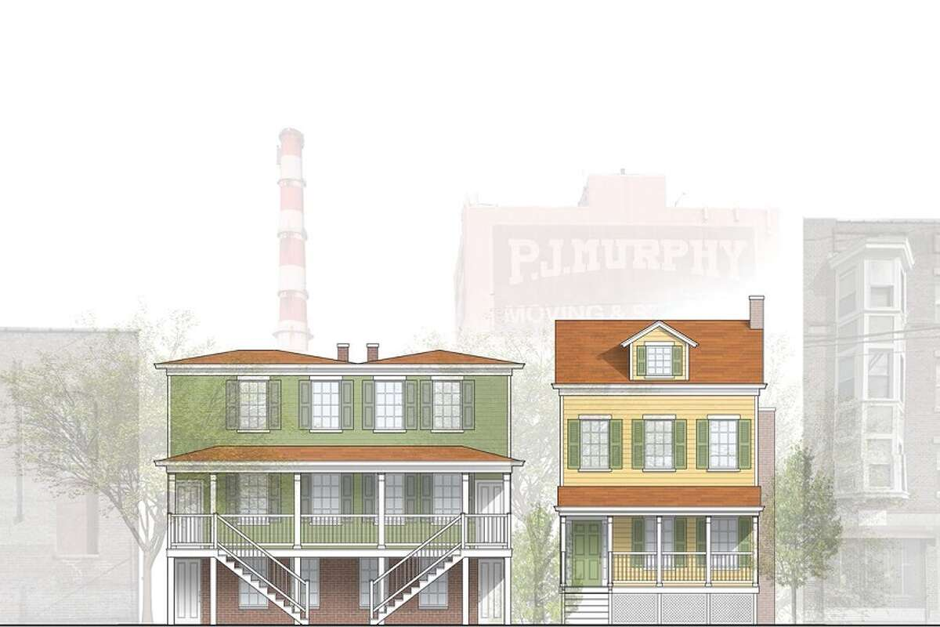

The current Mary and Eliza Freeman houses compared and sketch of renovated models by Northeast Collaborative Architects. Credit: Hearst CT Media / Northeast Collaborative Architects

Middletown's Northeast Collaborative Architects created architectural designs for the renovated houses. Synfoni Bailey-Green, one of the architects, said designs were created using information from the National Registry of Historic Places, touring the houses and from local historians.

"Especially for me, as a Black woman — one, there aren't that many of us as architects in the whole United States — but then to work on houses for sisters who in the 1800s owned them as rental property, that just wasn't something that was being done," Bailey-Green said. "The little piece that I can help touch on this makes me feel like I have a purpose."

The Freeman Center hopes to complete Eliza's house first — by June 2025. The first step to restoring the houses is stabilizing the existing structures and foundation, then restoring the exterior so they can withstand inclement weather. The plan also includes demolishing deteriorated portions of the houses and replacing them with additions that match the original design, but meet modern-day building codes. The houses will also have new gardens including plant multiple types of roses and lilacs and grape vines.

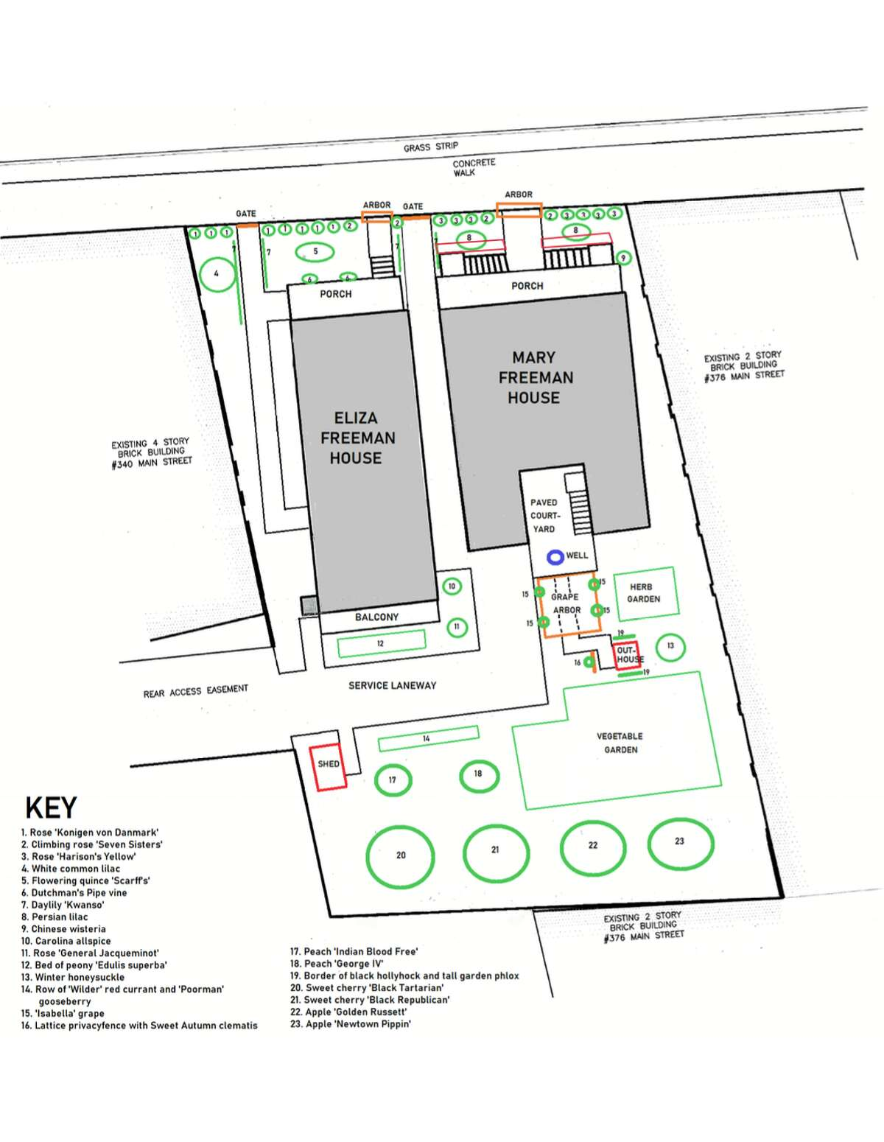

The design of the gardens of the restored Mary and Eliza Freeman houses.

Charles Brilvitch / contributed

Once complete, the Eliza Freeman House will operate as a gallery space for rotating exhibits. It will also serve as the home base for the volunteers of Resilient Bridgeport — a program to mitigate flood risk in the south east portion of the city. The house will also store supplies for to help the [surrounding community](https://gcc02.safelinks.protection.outlook.com/?url=https%3A%2F%2Fresilientbridgeport.com%2Fwp-content%2Fuploads%2F2019%2F10%2FResilient-Bridgeport-Record-of-Decision-Signed_102419.pdf&data=05%7C02%7CTodd.Levine%40ct.gov%7C8767fc3c093545af689a08dcf505abdf%7C118b7cfaa3dd48b9b02631ff69bb738b%7C0%7C0%7C638654651975747736%7CUnknown%7CTWFpbGZsb3d8eyJWIjoiMC4wLjAwMDAiLCJQIjoiV2luMzIiLCJBTiI6Ik1haWwiLCJXVCI6Mn0%3D%7C0%7C%7C%7C&sdata=Q61XNDzofHYc6clIoyI1pL229MESD9olERGH%2F8oPseQ%3D&reserved=0) with storm recovery.

The Mary Freeman House will operate as a museum, depicting the lives of Mary Freeman and her tenant, an African American minister. Visitors can view the antique interiors and furnishings, including pieces of 1800s kitchenware donated by The Westport Historical Society. The house will also be equipped with an elevator that services all levels.

"Bridgeport is looked at as not being the best place in the world by a lot of Connecticut," Bernicestine McLeod Bailey, chairperson of the Freeman Center, said. "To have this gem that throws light on the Bridgeport that existed, that very few people knew about and the fact that there is an opportunity for resurgence."

Freeman Center board member Adrienne Farrar Houel said that Connecticut has been very supportive of initiatives like the effort to restore the Freeman Houses.

"Fortunately, as I keep telling my husband, I'm so glad I live in Connecticut because I would be mad every day if I didn't," she said. "There is not much pushback here, there might be in other communities that I don't know much about but coastal Connecticut has been very supportive of this."