Prince Abdul Rahman Ibrahima Sori (1762-1829)

Posted on August 5, 2024
Contributed by: Roscoe Barnes III

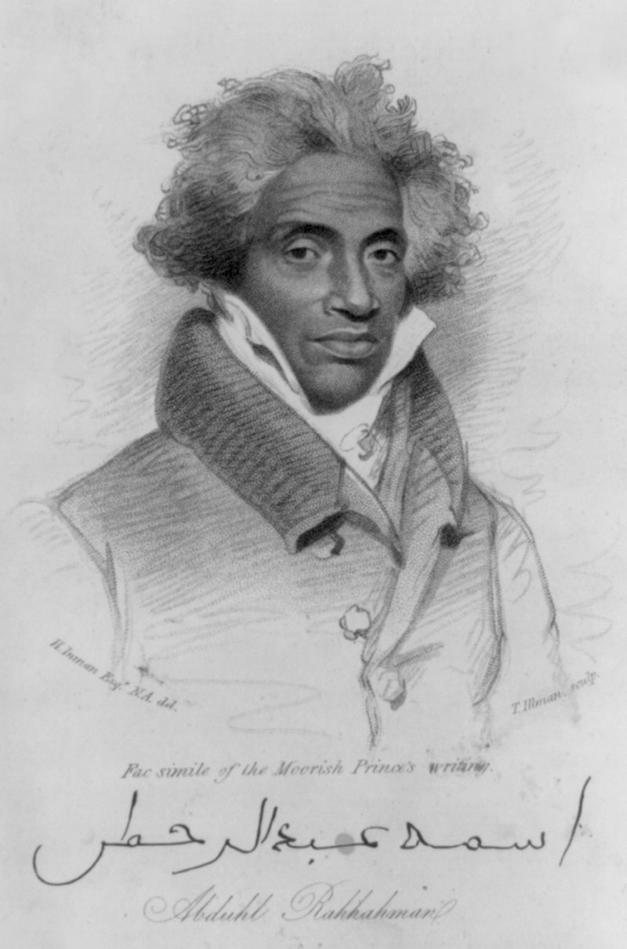
Abduhl Rahhahman by H. Inman, engraved by T. Illman.
Photo from the Library of Congress. Public Domain Image.

Prince Abdul Rahman Ibrahima Sori was an African prince who was captured in 1788 and sold as an enslaved man in Mississippi. He spent 40 years enslaved on a plantation in the Natchez area before he gained his freedom in 1828.
Abdul Rahman was born in 1762 in Timbuktu, a city in the current western African country of Mali. He grew up in Timbo, which was located in the Futa Jalon highlands of Guinea. His father, Ibrahima Sori Barry Mawdo, was a king who ruled as a political and religious leader in Futa Jalon.
At the age of 12, Abdul Rahman left home to study in the mosques at Timbuktu and Djenne in Mali, where he excelled in many subjects. By the time he completed his education, he could read and write in Arabic and speak five African languages. The prince returned home to join his father’s army and became a colonel by the age of 26.
In 1788, while returning home to celebrate a victory, he and some of his soldiers were ambushed by a rival ethnic group, the Hebohs. Abdul Rahman was captured and sold to slave traders. After being shipped to the United States, he was sold to a farmer named Thomas Foster, who owned a plantation near Washington, a village northeast of Natchez, Mississippi.
Although enslaved, Abdul Rahman stood out as an intelligent man of integrity who was deeply committed to his Muslim faith. Thomas Foster made him an overseer of the plantation.
In 1791, Foster purchased a woman in her early 20s named Isabella. She and Abdul Rahman married on Christmas Day of 1794. The two of them would raise nine children: five sons and four daughters.
In 1807, Abdul Rahman went into town to sell his produce when he saw Dr. John Coates Cox, a friend from his past. Cox was an Irishman who had sailed to West Africa in 1781. After going ashore, he became lost and later collapsed. He was rescued by the Fulani people and taken to Timbo, where Abdul Rahman’s father cared for him until his health was restored. After their chance meeting in Natchez, Cox tried for many years to buy Abdul Rahman’s freedom, but Foster refused to sell him. Cox died in December 1816.
In 1828, when he was 66, Abdul Rahman gained his freedom through the help of Natchez newspaper editor, Andrew Marschalk, and U.S. Secretary of State Henry Clay in President John Quincy Adams’ administration. Secretary Clay authorized Marschalk’s efforts to obtain Abdul Rahman’s freedom.
In February 1829, Abdul Rahman and his wife, Isabella, sailed to Africa. They repatriated to Monrovia, Liberia, which the American Colonization Society had created as a home for formerly enslaved Africans.
Several months after his arrival, however, Abdul Rahman contracted a fever. He died on July 6, 1829, at the age of 67. Isabella stayed in Liberia, and two of her sons later joined her. However, her other children remained enslaved in Mississippi and Louisiana. Isabella died around 1843.
--------------
See more at this link: https://www.blackpast.org/african-american-history/prince-abdul-rahman-ibrahima-sori-1762-1829/

Cite this entry in APA format:
COPY
Barnes, R. (2024, August 05). Prince Abdul Rahman Ibrahima Sori (1762-1829). BlackPast.org. https://www.blackpast.org/african-american-history/prince-abdul-rahman-ibrahima-sori-1762-1829/
Source of the author's information:
Allan D. Austin, “Abd Al-Rahman, Ibrahima” Oxford African American Studies Center (31 May 2013) https://projects.kora.matrix.msu.edu/files/16-23-92330/Ibrahima_Abd_Al_-_Rahman.pdf
Artemus W. Gaye, Ph.D. Dr. Isabella Rahman and the African Prince of Fouta Djallon (Alexandria: Forte Publishing International, 2023).
Terry Alford, Prince Among Slaves: The True Story of an African Prince Sold into Slavery in the American South (New York: Oxford University Press, 197

